# CS 255 System Design Document Template

This template lays out all the different sections that you need to complete for Project Two. Each section has guidance to prompt your thinking. You will need to continually reference the interview transcript as you work to make sure that you are addressing your client’s needs. There is no required length for the final document. Instead the goal is to complete each section based on what your client’s needs are. Remove this note when you are finished, and replace all bracketed text with the relevant information.

## UML Diagrams

### UML Use Case Diagram

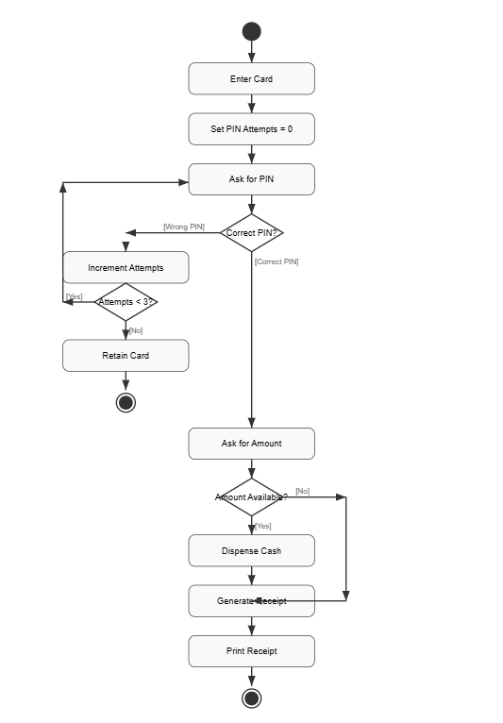

### UML Activity Diagrams

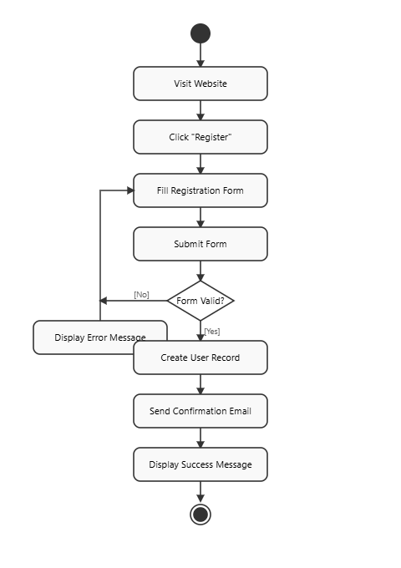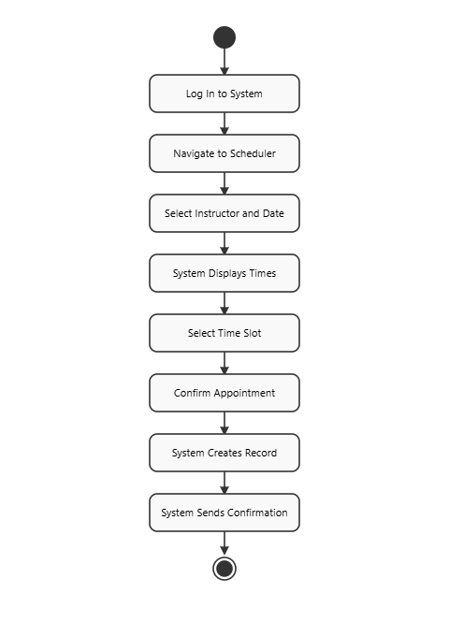

### UML Sequence Diagram

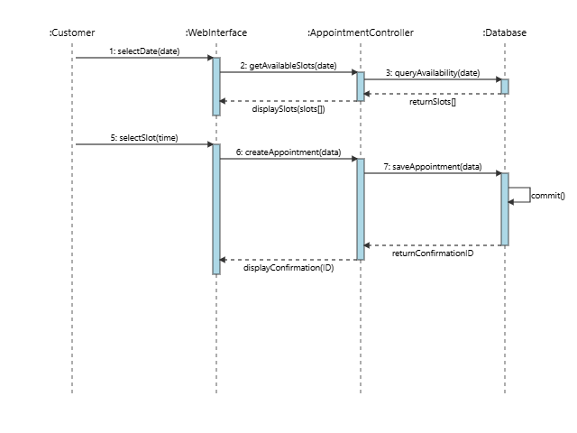

### UML Class Diagram

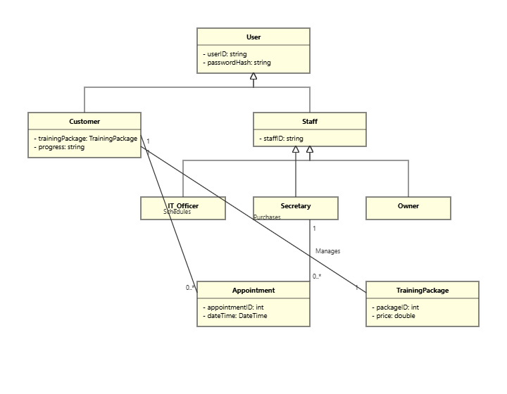

## Technical Requirements

### Technical Requirements

Based on the system design detailed in the UML diagrams, the following technical requirements are necessary for the successful implementation and operation of the DriverPass system. These requirements are broken down into hardware, software, infrastructure, and tools.

#### **Hardware Requirements**

* **Server Hardware:** As per the client's request to avoid on-premise server management, there are **no hardware acquisition requirements for DriverPass**. The system will be deployed on a third-party cloud hosting platform (see Infrastructure). The cloud provider will be responsible for provisioning, maintaining, and securing the physical servers, networking equipment, and data storage infrastructure.
* **Client Hardware:** End-users (both customers and staff) will require a standard computing device (desktop, laptop, tablet) with sufficient processing power and memory to run a modern web browser.

#### **Software Requirements**

* **Server Operating System:** The application will be deployed on a stable, secure Linux distribution, such as Ubuntu 22.04 LTS, managed by the cloud provider.
* **Web Server:** An Apache or Nginx web server will be used to handle incoming HTTP/S requests and serve application content.
* **Backend Application Stack:** The core business logic will be developed using a server-side scripting language like **PHP 8** or **Python 3.9** with a robust framework (e.g., Laravel or Django) to ensure rapid, secure development.
* **Database Management System (DBMS):** A relational database, such as **MySQL 8** or **PostgreSQL 14**, is required. The database must support transactional integrity to reliably manage user accounts, appointments, and payment information.
* **Client-Side Software:** Users must have a modern web browser that supports current HTML5, CSS3, and JavaScript standards. Supported browsers include the latest versions of Google Chrome, Mozilla Firefox, Microsoft Edge, and Apple Safari.

#### **Infrastructure Requirements**

* **Cloud Hosting Provider:** The system will be hosted on a major Infrastructure-as-a-Service (IaaS) provider, such as **Amazon Web Services (AWS)** or **Google Cloud Platform (GCP)**. This fulfills the client's requirement for a fully managed, scalable, and secure environment.
* **Network Security:**
  + All web traffic to and from the server must be encrypted using **HTTPS (SSL/TLS certificates)** to protect sensitive user data, including login credentials and payment information.
  + A cloud-based **Web Application Firewall (WAF)** will be configured to protect against common web vulnerabilities like SQL injection and cross-site scripting (XSS).
* **External System Integration (API):** A secure **RESTful API** must be developed or utilized to connect to the Department of Motor Vehicles (DMV) system. This API will be used exclusively for fetching updates to driving regulations to ensure the learning portal content remains current. All API communication must be authenticated and encrypted.

#### **Tools**

* **Version Control:** All source code will be managed using **Git**, hosted in a private repository (e.g., GitHub or Bitbucket) to track changes and facilitate team collaboration.
* **Development Environment:** Developers will use modern Integrated Development Environments (IDEs) such as Visual Studio Code or PhpStorm to write and debug code.